3-rd International Forum and Exhibition
“Intelligent Transport Systems of Russia”

APPLICATION FOR PARTICIPATION
(To be completed online)

Name of the participant company (organizational and legal form) in Russian and English | Name
Contact Person (full name)

Position

Telephone

Cell Phone
E-mail

CONDITIONS OF PARTICIPATION

Fee for participation in the Forum before July 1, 2018
□ 1-st Participant  Full name, position (title) – in Russian and English (telephone, e-mail) | 40,000 RUB
□ 2-nd Participant  Full name, position (title) – in Russian and English (telephone, e-mail) | 35,000 RUB
□ 3-nd Participant  Full name, position (title) – in Russian and English (telephone, e-mail) | 20,000 RUB

Fee for participation in the Forum between July 1-st and September 1-st 2018
□ 1-st Participant  Full name, position (title) – in Russian and English (telephone, e-mail) | 50, 000  RUB
□ 2-nd Participant  Full name, position (title) - in Russian and English (telephone, e-mail) | 45,000  RUB
□ 3-nd Participant  Full name, position (title) - in Russian and English (telephone, e-mail) | 25,000  RUB

Fee for participation in the Forum beginning from September 1-st, 2018
□ 1-st Participant  Full name, position (title) – in Russian and English (telephone, e-mail) | 60, 000  RUB
□ 2-nd Participant  Full name, position (title) – in Russian and English (telephone, e-mail) | 50,000  RUB
□ 3-nd Participant  Full name, position (title) – in Russian and English (telephone, e-mail) | 30,000  RUB

Fee for participation in the Exhibition (stand)
□ Exhibition Stand  (6 sq.m + 1 participant)  Stand No., Company, Full name, position (title) – in Russian and English (telephone, e-mail) | 125,000 RUB
□ 2-nd and subsequent Participant in the Exhibition  Full name, position (title) – in Russian and English (telephone, e-mail) | 20,000 RUB
□ Optional equipment  Plasma display (diagonal 50”) | 16,000 RUB

Stand Layout Plan:

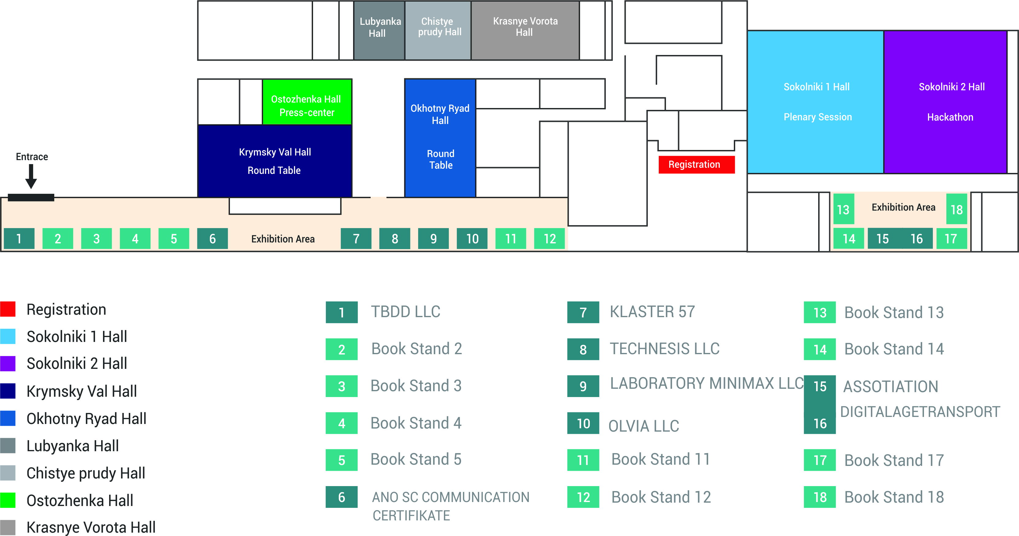

To submit an invoice, please fill out the following form with your Company’s particulars:

Full name of the Company
(specify organizational legal form)

Legal address

Actual address

Tax Payer’s ID No.

Industrial Enterprise Classification Code:

Settlement account:

Correspondent account:

Bank

Bank ID Code

Telephone, fax, e-mail

General Director (Full name)

By virtue of what document is he/she acting
(in case he or she is acting based on the power of attorney, please give No. and date as well as attach a copy)

NOTE:

Please note that the application completed and sent to the following address: info@itsrussiaforum.ru constitutes your consent to participate in the Forum or Exhibition as well as to enter into a legally binding agreement for participation or sponsorship with the Forum organizer J Comm LLC.
We would appreciate it if you could pay the invoice within 5 banking days and send your manager the payment instruction.

For further information, please contact us via phone:

If you have any questions about participation, partner interaction as well as about participation in the exhibition, please contact the event organizing committee on the following phone No.: +7 (495) 766-51-65

